Contents
3.1 - Analysis of the problem 1
3.1.1 – Problem identification 1
3.1.2 – Stakeholders 2
3.1.3 – Research the problem 2

3.1 - Analysis of the problem

3.1.1 – Problem identification

The Problem:
Sixth form students work hard throughout the year in order to achieve good grades in their A levels. Many of them like to play videogames to relax. However, these videogames are seldom beneficial to their education. I feel that linking these games to what they are learning in class could improve their performance at school. Therefore, I will create a game where the user has to hit projectiles at an object. However, to do so the user will need to use their mathematical and scientific knowledge to calculate how they will fire the projectile. For example, they may need to consider variables such as air resistance and gravity as these may change the motion of the projectile. The game will have many levels are get progressively harder as the difficulty of the calculations required increases.
Why the problem is solvable by computational methods:
This problem is solvable by computational methods because the calculation of the projectile path would be done by an algorithm which would take in inputs such as gravity, angle of release and speed of release and then output the motion of the projectile onto the screen via an animation.
Problem recognition:
The overall problem is being able to accurately animate the path that a projectile will take. The underlying problem is calculating the path that the projectile will take by taking into account the variables that may affect its motion. When the underlying problem is overcome, the rest of the solution is simply applying the information relating the motion of the projectile to the animation so that the user can easily see what happens.
Problem decomposition:
This problem can be decomposed into smaller steps.
For each level in the game:
- Set up projectile and target at certain distances and angles away from each other.
- Set up the variables such as terrain, air resistance, gravity.
- Allow the user to input the speed and angle of release of the projectile
- Use mathematical calculations to work out the motion of the projectile and see if it hits the target.
- Animate this, making sure to account for the scale of the screen and other potential computer configurations.
Use of divide and conquer
The overall problem can be divided into these smaller steps. Each of these steps can then be conquered individually and combined together to make the final program. Using this method means that the complex overall problem is split into more manageable smaller problems which makes development easier.

3.1.2 – Stakeholders

The users of my game are people that are interested in playing videogames but also want to be intellectually challenged whilst playing. My main stakeholder will be David Kuc, who studies Physics and Mathematics at A level and likes playing computer games. This game will benefit him by allowing him to recap two vital areas of those subjects: kinematics and projectile motion. He wants a game that is fun, has good mechanics and challenges him to use mathematics to progress.

3.1.3 – Research the problem

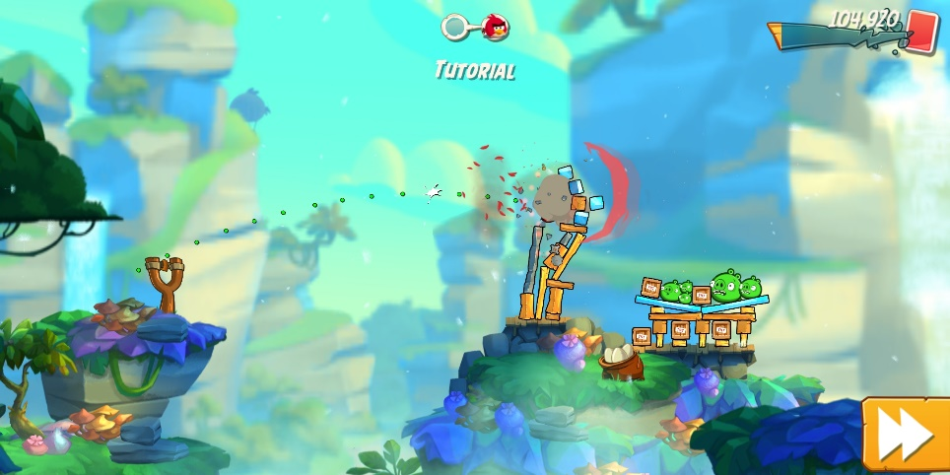
Existing Similar Solution 1 – Angry Birds 2:
‘Angry Birds 2’ is a game where players use a slingshot to launch birds at nearby targets. The game can be played on multiple platforms but I tested the game on a mobile phone. The slingshot is directed using hand movement on the screen. The game shows the path that the bird will take using green dots. The game has music in the background. There are multiple levels and the difficulty increases as you progress.
There are many features of the game that I like and can apply to my solution. Firstly, I like how the game shows the user the path that the bird will take and I will incorporate this feature in my game. Secondly, the graphics of the game are very good and the game is in 3d. Whilst my game will be in 2d, I will certainly include a similar level of detailed graphics. The slingshot is easy to control and adjust using hand movement so I will make sure that my projectile is also easy controllable and adjustable either through sliders or mouse movement. I like how the game has rewards for hitting targets so I will develop a scoring system and score board.
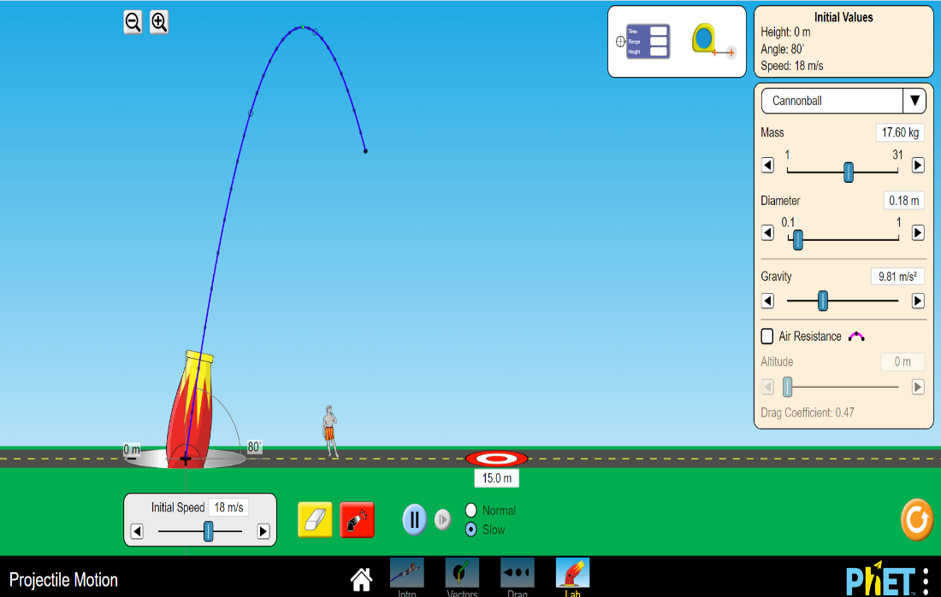
Existing Similar Solution 2 – PhET Projectile Motion:

‘PhET Projectile Motion’ is a simulator where you can fire projectiles. It is not a game but is instead used for educational purposes.
There are several features of the simulator that I like and can apply to my solution. Again, I like how the simulator shows the path that the projectile takes using a series of blue dots connected together with a blue line. The angle of the projectile is easily adjustable through mouse movement and similarly the speed of the projectile is easily changed through a slider bar. These are features that I will certainly apply to my own solution. A very handy feature is one where you can change the speed of the animation. I will include this useful in my own solution as the user can more easily see the path that the projectile will take.
Survey
I conducted a survey to find out the general features that my users wanted from my solution. I decided to ask the following questions:
- How big should the game screen be?
- How would you like to fire the projectile?
- Do you want the game to save your progress?
- What would be your preferred method of playing the game?
- What features would you like the game to contain?
- If you have ever played a similar game, what features did you like?
- Would you like music in the game and if so, what type?
- Any other comments
Results of Survey
Q1: How big should the game screen be?
- Full screen [42.86%]
- Adjustable window [57.14%]
Q2: How would you like to fire the projectile?
- Entering values manually [42.86%]
- Slider bar [57.14%]
Q3: Do you want the game to save your progress?
- Yes [85.71%]
- No [14.29%]
Q4: What would be your preferred method of playing the game?
- Computer/ Laptop [85.71%]
- Mobile phone [14.29%]
- Other [0%]
Q5: What features would you like the game to contain?
- It should be fun, not too ugly and not boring or too challenging. It should have different levels or difficulties.
- Some kind of goal - i.e. a reason to play the game. Maybe make an adventure mode or something with different levels of difficulty as you progress.
- Choice of colour for the projectile
- Good graphics.
- Projectile skins.
- Easy controls.
Q6: If you have ever played a similar game, what features did you like?
- Angry birds: it had intuitive controls and was fun.
- The game would report back on how close/far I was.
- Angry birds had fun physics and structures to destroy. Was pretty satisfying.
- The sound when the object hits the target or misses it.
- Chain reactions objects, like hit an explosive barrel to cause a greater effect.
- Being able to aim easily.
Q7: Would you like music in the game and if so, what type?
- Yes. Ambient or relaxing music. It can be fast paced energetic music if it suits the game, but it shouldn't be too distracting. There should always be an in-game option to turn music and sound effects off.
- Yes. Any kind is fine. If it's not too complex, making the option to switch between different tracks might be nice.
- Yes. Instrumental music.
- Yes. Happy uplifting stuff.
- Yes. Upbeat music.
- Yes. Chiptune could be cool
- Yes. Non distracting.

Analysis of Survey
From the answers to first two questions, I can see that there is no overwhelming consensus from my users about the size of the screen and the method of launching the projectile. Questions 3 and 4 show me that my users want the game to save their progress and would prefer to play the game on a computer/laptop. The last few questions were more open and therefore I received a wide range of opinions and ideas from which I can make some specific specification requirements.

Interview with main stakeholder
Once I had the results of the survey, I decided to conduct an interview with my main stakeholder. I asked him (David Kuc) the same questions but was looking to gain more detailed and specific answers, especially where the opinions from my survey had been more unclear.
- How big should the game screen be?
I would like it to be an adjustable window. There are a few reasons why.
Primarily, by using an adjustable screen, the user can easily switch between the game and other applications at will without the hassle of the processor having to refocus other tasks.
Also, an adjustable screen can be resized to the desirable size and resolution by the user.
Overall, an adjustable screen is more beneficial for using other applications simultaneously which is why I prefer it.
The only downside to an adjustable screen is that the CPU and GPU are also being used by other processes so you may experience lag or limited FPS. Though given that this game is unlikely to use excessive amounts of processing power, it isn't much of an issue.
- How would you like to fire the projectile?
A slider bar system would be preferable. This is because it allows the user to adjust the values without having to type them in.
This decreases the accuracy of the number selection; however, it is a lot easier to slide a bar than manually type out a value.
For this game, it is unlikely that the user will need to be too specific about their values, which is why I'd recommend focusing on usability over accuracy.
- Do you want the game to save your progress?
Yes, definitely.
- What would be your preferred method of playing the game?
I would like to play the game on my laptop.
- What features would you like the game to contain?
I think that generally, users like customisability. You shouldn’t restrict the users by using set systems for everything, but instead try to allow for options and variety wherever possible.
The more that a user can customise the game; the more likely they are to do so. And if a person spends a long time setting something up, they are unlikely to give up all of that effort easily, so it’s another way of drawing players in and having them keep playing.
- If you have ever played a similar game, what features did you like?
I have played Wii bowling and Angry Birds. However, I have played a variety of other games where you need to complete similar objectives as side tasks or minigames.
I liked having to avoid obstacles, and having other external elements act on the system like wind and gravity.
- Would you like music in the game and if so, what type?
Yes, but the music should depend on the theme of the game. For example, if the setting is in space, then the audio should complement that setting.
I’d recommend creating a variety of themes, which can either be toggled by the player, appear randomly, or occur for certain predetermined levels, where the background, sprites and music all change and are all linked together.
For example, if there is a nature theme where the background is a forest, the sprites should be natural colours and the music should be like something from ‘The Hobbit’.

Analysis of Interview with main stakeholder
The answers to Q1 and Q2 showed a clear preference for an adjustable window size and a slider bar system. The answers to the next two questions reflected the same opinions that I had gained from my survey, and therefore confirmed that my game should save progress and be computer based. The answer to Q5 was particularly helpful, and showed that I should try to give the users of the game as much flexibility and control as possible. The answer to Q6 gave me an idea of the successful features of similar games. The answer to the last question again linked back to giving the users flexibility and options.

Essential features of project
From conducting the survey and the interview, I was able to find out what the essential features of my project should be.
- Game window will be an adjustable window
- Projectile will be fired using a slider bar
- The game will save progress
This will require implementing a registration/login system and storing data about users and their corresponding levels in a database.
- The game will be computer based
This will require the game to be created as an executable application rather than a mobile application.
- The game will have several levels
This will give a purpose to the game and allow the game to increase in complexity as the user progresses.
- External elements will impact the game
This will allow each level of the game to be unique as the settings and variables that need to be taken into account will change
- The game will give users feedback on their performance
This will allow users to improve and become better, the more they play.
- The music will change depending on the level. Users will be able to turn music on/off.
This will allow the music to better reflect the situation in the game. It will also give user the option of turning the music off completely if they so prefer.

Limitations of the solution
The main limitation of my solution will be the precision of the projection motion calculation. This is because the calculation will involve imprecise values. For example, a slider bar system will limit the precision to which the user can specify the speed of the projectile. This will mean that the calculations carried out by the program may result in values that are slightly different to what the user intended.
To fix this limitation, I will include a margin of error in all calculations meaning that slight variations in values will be accepted. This will make it easier to users to hit the target with their projectile.

Software and hardware requirements
Requirement | Type | Justification
Windows/Linux/UNIX/Mac OS X | Software | These operating systems are supported by Python.
Keyboard & Mouse | Hardware | Needed to operate the program.
Python interpreter | Software | Needed to translate Python code into machine code.

